Numerical Illustration of Decision Tree

Sample Dataset: Play Tennis (Classification)
Target Variable: Play (Yes / No)
Dataset (14 records):
ID | Outlook | Temp | Humidity | Wind | Play
1 | Sunny | Hot | High | Weak | No
2 | Sunny | Hot | High | Strong | No
3 | Overcast | Hot | High | Weak | Yes
4 | Rain | Mild | High | Weak | Yes
5 | Rain | Cool | Normal | Weak | Yes
6 | Rain | Cool | Normal | Strong | No
7 | Overcast | Cool | Normal | Strong | Yes
8 | Sunny | Mild | High | Weak | No
9 | Sunny | Cool | Normal | Weak | Yes
10 | Rain | Mild | Normal | Weak | Yes
11 | Sunny | Mild | Normal | Strong | Yes
12 | Overcast | Mild | High | Strong | Yes
13 | Overcast | Hot | Normal | Weak | Yes
14 | Rain | Mild | High | Strong | No

INFORMATION GAIN

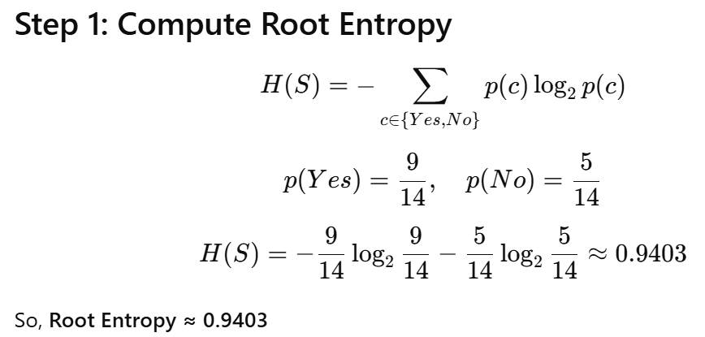

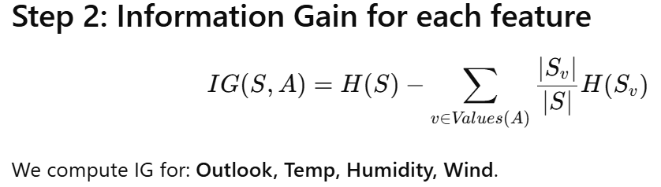

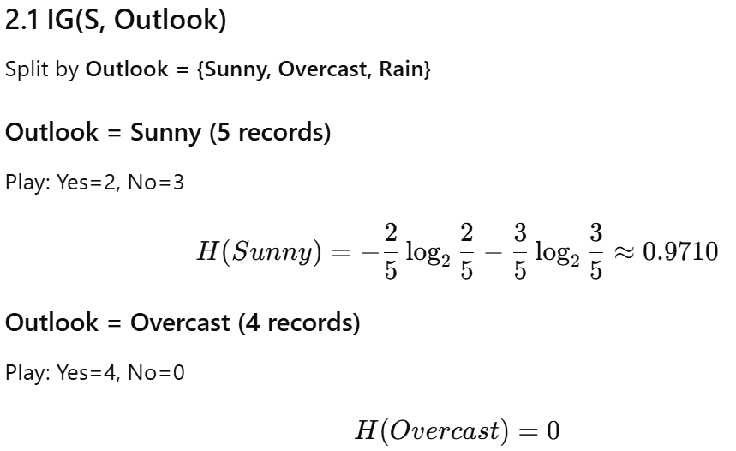
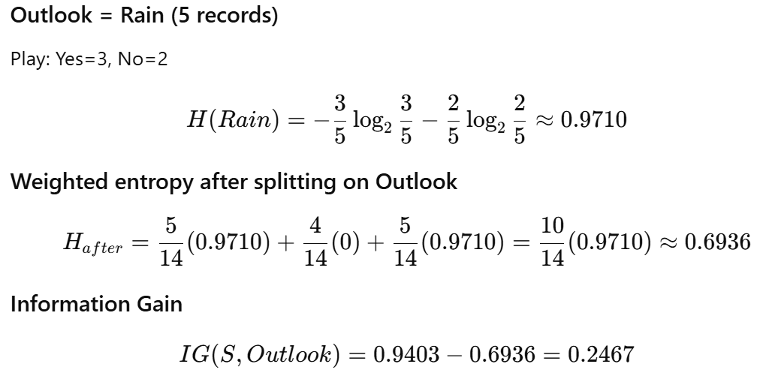
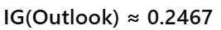

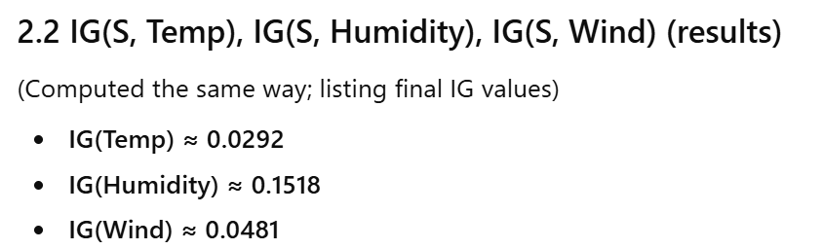

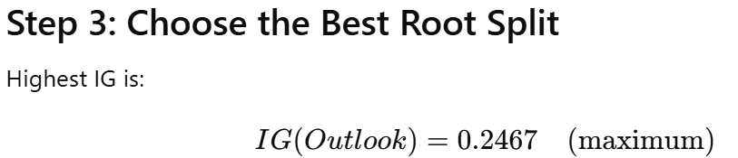

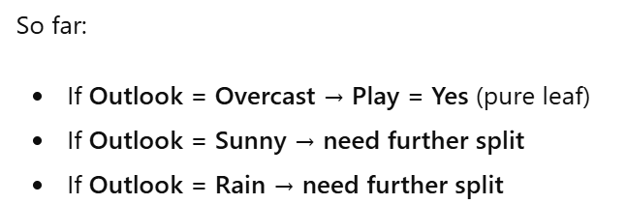

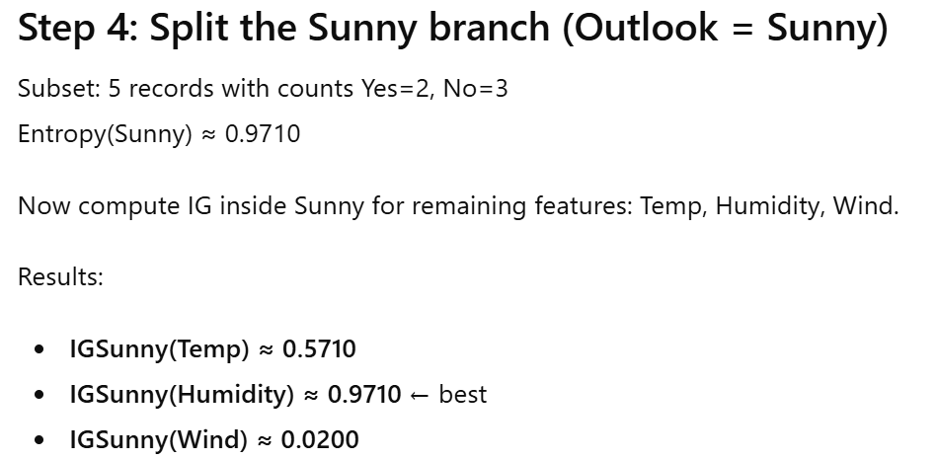

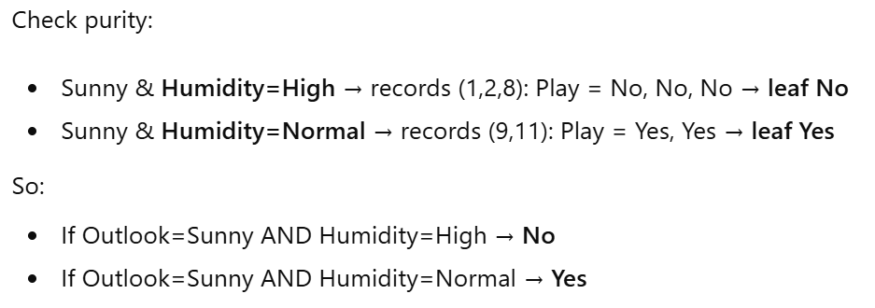
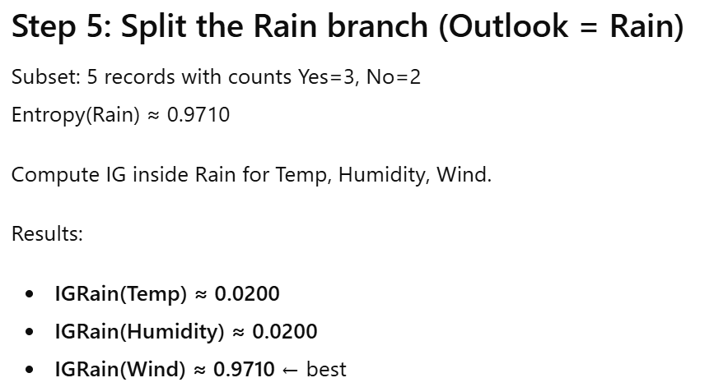

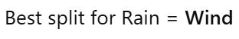
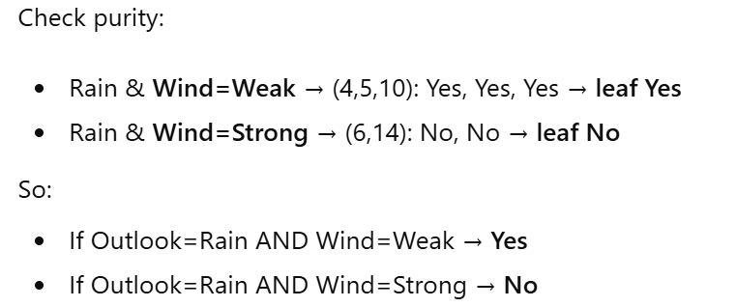
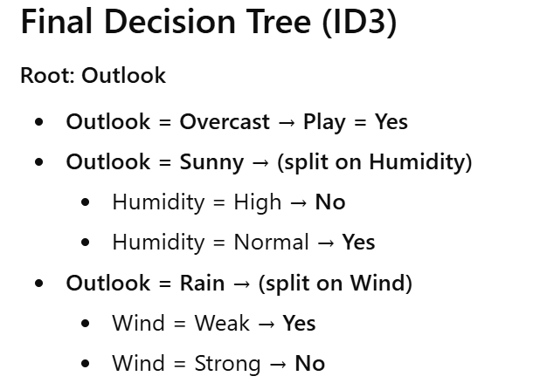
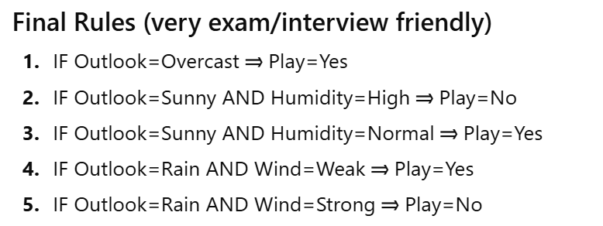
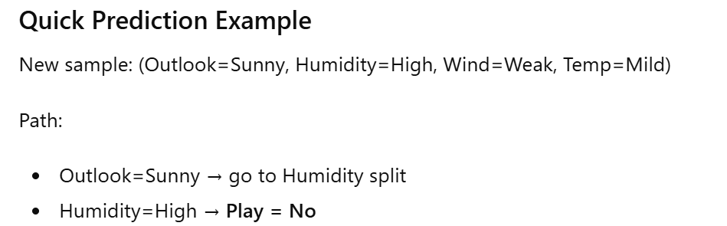

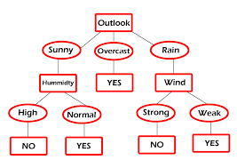

GINNI IMPURITY
